|  |  |
| --- | --- |
| PGYTECH OneGo Air 25L camera backpack  Balo máy ảnh PGYTECH OneGo Air 25L (Obsidian Black)  PGYTECH ONEGO AIR 25L PGYTECH ONEGO AIR 25L 1 | **Featured information:**  Capacity 25LMagnetic lock opens and closes with one touchCustom storage spaceMaximum load 12kg  Price : $ 180  **Specifications:**  Volume  20L, 25L |

**Overview:**

PGYTECH OneGo Air 25L Backpack is a highly applicable camera backpack that serves the needs of many different types of photographers. With a completely open clamshell design, OneGo Air 25L provides an optimal storage space and many extremely convenient features, helping users have the most comfortable experience.

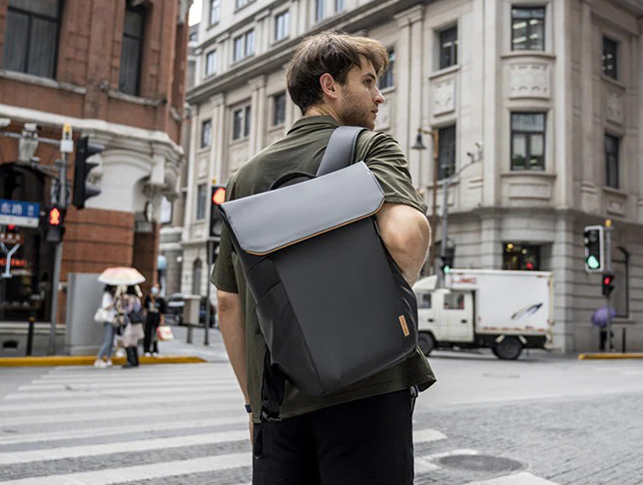

OneGo Air 25L scores strong points with its ultra-light design of only 1.65kg. This modest weight ensures flexibility and convenience every time you move. Combined with an EVA back design that helps reduce pressure and weight on the body, the backpack can serve essential storage needs to professional shooting equipment.

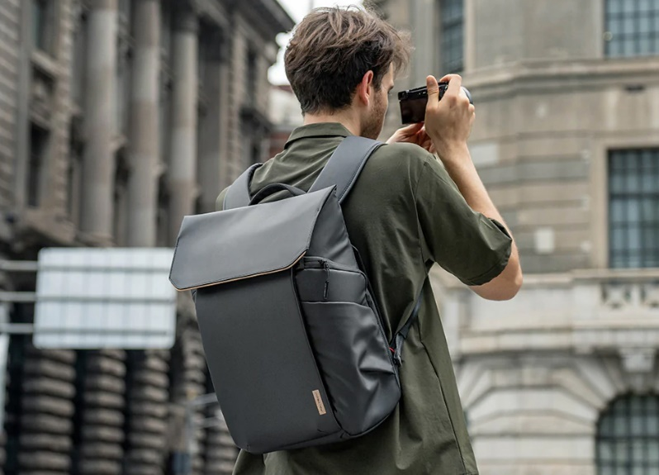

PGYTECH OneGo Air 25L backpack divides the internal compartments with flexible adjustable partitions. The "ModulePro" system includes removable compartments that can serve a variety of storage purposes. Thanks to that, photography equipment is stored more neatly and safely, helping users access the equipment easily and quickly.

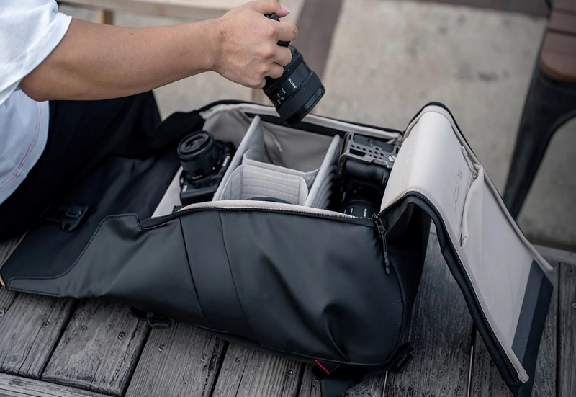

PGYTECH OneGo Air 25L camera backpack is made with a combination of two high-quality materials: polyester and PU high-performance coating. Therefore, the backpack is water-resistant, scratch-resistant, and durable both indoors and outdoors. Except in cases of extreme weather conditions or exposure to wet environments for too long a period of time, the backpack can safely protect your device.